GTAMS Design Documentation

Design Change-Log:

3/29/2016:

Cache of prototyped application pages made and added for future development.

4/5/2016

GTA application page had added support of automatically generated timestamps. Links were added to the pages for better navigation between the current homepage and the subordinate pages. The page which contained the information on incomplete nominees was revamped to resemble the future production instead of just being a complete placeholder.

4/7/2016

The GTA application page had a prototyped automated email system added to it. The score table page was altered to allow for input and altering score values, as well as allowing for comments to be added below the scores. The score table was converted from a static table to an actual submission field. The links to the incomplete nominees page were added to the score table page as per the project description.

4/7/2016

The user interfaces for the GTAMS project were split up and organized in a fashion more resembling the project description. Login page still under development, so temporary backdoor links were added to allow for development work while the database was being set up.

4/8/2016

System administrator user interface added to the html cache, as well as the account information altering page. Recurring variable names were addressed and fixed to prevent issues with record keeping.

4/12/2016

User interface for academic advisors added to the html cache, along with functionality to input a letter of reference via text input or file upload.

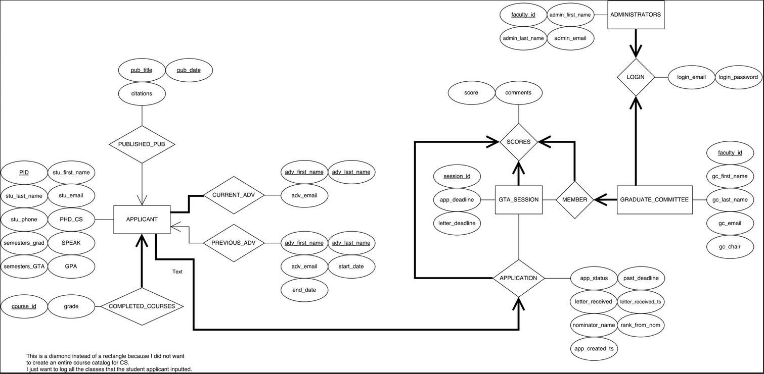ER Diagram of our created database:

By setting up our database in this fashion, we were able to ensure that we could keep track of all of the necessary data-fields, and at the same time keep it from being overly complex. Our database allows us to separate the privileges of different users based on their credentials, and determine what they have access to, and what they are restricted from. Overall, this design should allow for our data to be both accessible, and organized in a logical manner.